

Equity, Diversity & Inclusion Action Plan

Our Vision

“Provide an inclusive environment which allows the game to be accessed and enjoyed by all”

Our Mission

“Lead, inspire and provide a duty of care in the continued growth and improvement of cricket in Suffolk”

Our Values


Inclusiveness
Providing equal opportunities regardless of sex, age, disability, ethnicity, nationality, sexual orientation, religion or other beliefs. This includes treating all people equally, listen and respect others and embrace who we are, what we do & how we do it.

Wellness
Cricket activities & communities to help with Emotional, Physical and Social wellbeing
- Safeguarding – duty of care for everyone
- Emotional – support colleagues
- Physical – promote active lifestyle
- Social – positive social relationships



Accountability
Ownership of what we do
- Be open & transparent
- Take responsibility


Fairness
Adopt and support the “Spirit of cricket” in everything we do.
- Never judge
- Lead by example
- Operate with honesty, respect and kindness


Inspire
Provide a positive experience for all
- Care about what we do
- Strive to be the best
- Enthuse generations

Collaboration
Work together to achieve desired outcomes
Listening & learning from everyone

LAA | Total Pop | Total ED as % of LAA Pop | Asian % of LAA Pop | Active Clubs 2023 | Population / Active Club
East Suffolk | 246064 | 4% | 1% | 23 | 10698
West Suffolk | 179942 | 8% | 3% | 20 | 8997
Ipswich | 139631 | 16% | 5% | 7 | 19947
Mid Suffolk | 102690 | 3% | 1% | 17 | 6041
Babergh | 92336 | 3% | 1% | 18 | 5130

It’s not just cricket in Suffolk!

Suffolk has a population of 757k individuals, c.144k of whom are estimated to be interested in cricket (“cricket interested”)

Suffolk’s population is predominantly of white ethnicity, at 93% of the population (national average = 86%), and over-indexes in the 60+ age bracket (31% of the population, national average = 22%), whilst 60% live in rural areas (national average = 24%)

Ipswich has the highest proportion of BAME residents in Suffolk (13.5% of the population) and Women aged 16-45 (19.9% of the population). Forest Heath has the highest proportion of 5-8s (5.7% of the population) and Under 16s (20.8%)
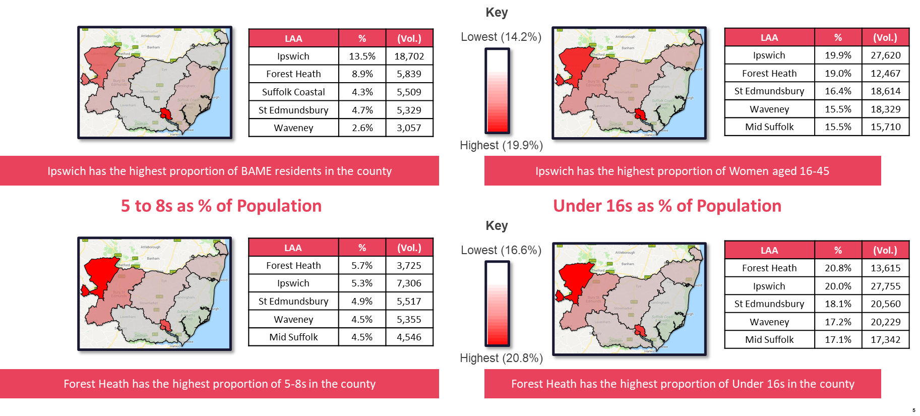
Suffolk Cricket Limited (SCL) is reflective of the county’s demographics

 | Suffolk Cricket Limited 2022 | Suffolk Cricket Limited 2023 | Suffolk Cricket Limited 2024 | Recreational Game 2023 | Recreational Game 2024 | England & Wales Population
Sex
Female | 14% | 20% | 33% | 31% | 32% | 51%
Male | 86% | 80% | 67% | 68% | 66% | 49%
Age
Under 30 | 29% | 20% | 15% | 25% | 26% | 36%
31-50 | 36% | 40% | 38% | 42% | 45% | 26%
50+ | 36% | 40% | 47% | 32% | 29% | 38%
Ethnicity
Ethically diverse | 7% | 10% | 7% | 13% | 11% | 8%
White | 93% | 90% | 93% | 86% | 88% | 91%
Lower Socio-Economic background | 21% | 20% | 31% | 13% | 29% | 39%

The above table shows Suffolk Cricket Limited collated survey responses, completed by Suffolk Development team and Board over the past three years (2025 results pending).

As you can see our female representation has increased from 14% in 2022 to 33% in 2024. A main part of this is that are Board (total 11 people) now comprises of 5 females (45%)

Overall the people working for Suffolk Cricket Limited reflect the demographics of our county.

Suffolk Cricket are committed to ensuring EDI is integral to everything that we do, from a strategic point of view to policies, operations and work programmes. Our following Vision hopefully demonstrates that;
Suffolk Cricket is for Everyone
Objective 1  Building diverse teams  Recruit, retain and support a diverse workforce | Objective 2  Inclusive Environment  Offers to meet Suffolk’s diverse needs, abilities | Objective 3  Building EDI capability Leadership & Education | Objective 4  Leadership & Governance  Monitoring, reviewing & reporting
ACTIONS  Review recruitment policy and processes in order to adopt a fairer, more equitable system with the aim of having a workforce reflective of the Suffolk community | ACTIONS  Ensure a welcoming, safe environment through engaging with relevant community individuals, communities and organisations – addressing barriers/improving access through suitable and sustainable offers | ACTIONS  Develop awareness and deliver training across SCL linking to and learning from/with external organisations e.g Community Action Suffolk, Suffolk Football Association, Active Suffolk | ACTIONS  Review governance documents – strategy/business plan, policies and operational processes  Ensure that EDI is reflected in all planning, delivery and reporting including KPIs and data collection  Implement review and appraisal system for board and team members  Establish a formal Board EDI Sub Group to oversee EDI and to be responsible for reporting to Quarterly board meetings

- Building Diverse Teams by Recruiting, retaining and supporting a diverse workforce

Tasks | Owner | Timeframe / Review | Success measure | Reporting / Monitoring
- Review recruitment documentation and practice through an EDI lens  - Advert & Recruitment Pack  - Inclusive language  - Role descriptions  - Criteria  - Person specification  - Ensure clear requirements and expectations from the role | Board | Annually or when recruiting | Policies adopted | - Initiate with board appointments and following same principles for all recruitment (eg Women’s County Coach)
- Ensure diverse recruitment panels – shortlisting and interviewing | Board | Ongoing | Applicants from non-cricketing backgrounds / under represented communities | - Process in place for diverse interview panels  - Also included practical interview where applicable
- Promote vacancies in the wider community (targeting communities / groups underrepresented within Suffolk Cricket) | Operations Manager | Min 1 month in advance | Pack updated | - Used various platforms to promote
- Have informal conversations with shortlisted candidates and check if there are any barriers to be addressed | Recruitment Panel | Ongoing | EDI Director & Board approval | - Candidates spoken to
- Deliver EDI information as part of inductions | Recruitment Panel | Ongoing | Minimum one person from each sex, including independent.
- Identify key individuals within targeted communities with a view to establishing champions, confidence and trust to encourage applications | Recruitment Panel / EDI Lead | Min 1 month prior to interviews | All needs met prior to interview | - Still need to work on identifying key people
- Discuss and agree staff flexible work arrangements needed | EDI Board Director | Within 1 month of appointment | Induction completed | - Will assess each case individually

- Inclusive Environment - Cricket offers to meet Suffolk’s diverse needs, abilities

Task | Owner | Timeframe / Review | Success measure | Reporting / Monitoring
- Engage with relevant communities / organisations / individuals (eg BSC Multicultural Services, Active Suffolk, Local Authorities) – some as delivery partners and others in a support capacity where SCL can help them meet their objectives | RJ / A Blanchard | 31/06/25 | Key communities contacted, feedback obtained. | - Lots of activity happening within this space to work with diverse communities
- Implement a satisfaction survey for team and board members where EDI is included | EDI sub-committee | 31/06/25 | Minimum 90% completion rate | - Utilise ECB satisfaction annual survey  - Review local requirements for survey
- Establish an annual stakeholder survey where EDI is included | EDI sub-committee | 31/06/25 | Feedback obtained | - Need to establish stakeholder survey
- Identify the barriers with respect to engaging with Suffolk Cricket and cricket activity | Development Team / EDI sub-committee | Ongoing | More diverse demographic of players / volunteers | - Demographics of SCL in line with Rec Game & Suffolk’s population
- Collaborate with Active Suffolk as part of the Sport England Place Based work. Adapt cricket offers to meet the needs of the respective local community | EDI sub-committee | 31/06/25 | Working in partnership | - In progress (In contact with Tony Bush (Ops Director) & Terry supporting collaboration)
- Build capacity in the local community through signposting, advertising and training based on their need. | Development Team / EDI sub-committee | Ongoing | Sustainable community cricket offers | - Mar 25 – Secured EDI funding to extend & target Ipswich Community offer
- Work within a multi-agency approach to maximise effectiveness | Development Team | Ongoing | Evidence of partnership working | - Work with BSC, FA, Royal Benglas Sports Association

- Building EDI capability - Leadership & Education

Task | Owner | Timeframe / Review | Success measure | Reporting / Monitoring
- Recruit specific EDI Board and Team Leads | Board / RJ | 31/12/23 | Board lead appointed | - EDI board lead appointed
- Deliver ECB and other training as needed with respect to EDI to both team and board members including jointly | EDI Board Lead / sub-committee | 31/07/25 | All complete EDI training | - Team receiving EDI training (eg Unconscious bias 07/04/25)  - Inclusive Leadership completed
- Deliver specific EDI training to all involved in recruitment including interviewing | EDI Board Lead | Min 14 days prior to interviews | Interview panel trained
- Identify EDI training needs (including succession planning) via quarterly (team) and annual (staff and board) appraisal process | EDI Board Lead / RJ | Quarterly / Annual reviews | Documented training needs identified | - Training needs being identified and implemented, continue to review
- Deliver EDI training to individuals and groups in the community which will be responsible for local co-ordination and delivery (promote bursaries for training as required) | EDI Board Lead / RJ | Ongoing | Local training initiatives | - Bursaries now being regularly used for coaching courses, leading to more diverse representation
- Collaborate with and learn from other organisations including seeking access to training opportunities – avoiding duplication where possible e.g Suffolk FA, Active Suffolk | EDI sub-committee / Development team | Ongoing | Multi agency working | - Work to be progressed

- Leadership & Governance - Monitoring, reviewing and reporting

Action: Appraisal system for Board members & employees
Task | Owner | Timeframe / Review | Success measure | Reporting / Monitoring
- Establish a formal EDI Board Sub Group which will have a clear overview of EDI at both strategic and operational levels continually reviewing and updating the EDI Plan | EDI sub-committee | 31/07/25 | EDI Sub-committee formed | - EDI sub-committee established  - Need to ensure regular sub-group meetings
- Review governance documents in order that EDI is embedded in strategy, policies and operations | Board / EDI sub-committee | 31/05/25 | Governance documents reviewed | - Implement as part of new Strategy (May 25)
- EDI will be an agenda item at quarterly board meetings which will include an EDI report with proposals for board approval as appropriate | EDI Board lead / RJ | Ongoing | Board agenda item | - EDI included on all Board meetings
- Submit EDI data with respect to team and board as part of ECB data gathering | EDI sub-committee | Annual | Submitted to ECB as required | - Submitted as requested
- Update the Suffolk Cricket EDI data on an annual basis in order to track progress and help with targeting actions | EDI sub-committee | Annual | EDI data published on website | - Plan published on SCL website and updated quarterly
- Implement an appraisal system which includes both team and board members | Board / EDI sub-committee | Quarterly / Annual appraisals | Documented appraisals | - EDI Board lead provided colleague and Board appraisal form. Used by team, to be adopted by Board Apr 25
- Collaborate with neighbouring County Boards in order to learn, share good practice and delivery as appropriate | RJ (& EDI sub-committee) | Ongoing | Evidence collaboration | - Joint training events (07/04/25)
- Share EDI objectives and progress on achieving them with key stakeholders (please see objectives below) | Chair / EDI sub-committee / RJ | Annual | EDI objectives shared | - EDI objectives to be agreed & updated by Board  - Sub-committee meetings regularly take place to discuss progress
- Ensure EDI is factored into programme planning, delivery and features in monitoring and reporting | EDI sub-committee / RJ | Ongoing | EDI included as required
- Collate impact reports | EDI sub-committee & Dev Team | Ongoing | Minimum 4 case studies submitted every calendar year | - Subject to agreement from those concerned, published on website  - As above, shared with key stakeholders

Action: EDI Objectives
Task | Owner | Timeframe | Success measure | Reporting / Monitoring
- Community Programmes | AB | Mar 2025 – Sept 2025 | - Create a minimum of 2 exit routes within the community
- Support stakeholders in developing the cricket offering in Ipswich | AB | Dec 2024 – Dec 2025 | - Increase provision and participation of cricket activities in Ipswich by 20%
- National Programmes (Girls) | AB (AR / LN) | Feb – August 2025 | - 12% increase in All Stars registrations (170)  - 14% increase in Dynamos registrations (78) | - Local updates & National report
- Women’s softball cricket | AR / LN | Dec 2024 - Sept 2025 | - All affiliated clubs contacted with offer  - 75% fixtures played | - Affiliation & Play-Cricket
- Talent Pathway (Girls) | BW / EEP Lead | Aug 2025 – May 2026 | - Girls u12’s EEP  - Additional u14 & u16 Girls CAG squads | - Early Engagement to Performance Lead
- Disability cricket | JS (EG / AR) | By July 2026 | - Minimum 2 successful (min 5 players at each) disability community hubs | - Player attendance

