

SUFFOLK CRICKET LIMITED

CANDIDATE BRIEFING and RECRUITMENT PACK
Fundraising and Marcomms Officer
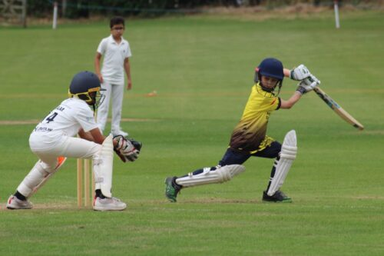

Contents

About Suffolk Cricket Limited 3

The Opportunity 4

Role Overview 5

Applications 6

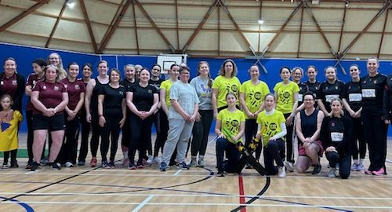

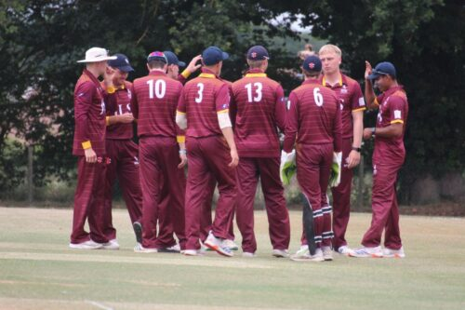

About Suffolk Cricket Limited
Suffolk Cricket Limited (SCL) is one of 39 County Cricket Boards, across England and Wales. Its primary funder is the England & Wales Cricket Board (ECB), which has committed to another 5 years (2025 – 2028 inclusively) of funding through the latest strategy, entitled “Inspiring Generations”. Working with the ECB, SCL have developed a County Partnership Agreement (CPA) Plan, which strategically shows the priorities and organisations that SCL will engage with over this period. One of the key principles is to connect with communities and inspire future generations to say “cricket is a game for all”.

SCL is the result of a recent merger between Suffolk Cricket Board Limited and Suffolk County Cricket Club.

The Suffolk Cricket key priorities include:
- Helping ensure cricket is a game for everyone
- Supporting clubs, players, volunteers, leagues and Associations (e.g. Grounds, Umpires & Scorers, Coaches)
- Retaining and increasing the number of players and volunteers in the game by reaching new audiences
- Delivering ECB National programmes locally (e.g. All Stars Cricket, Dynamos, Ladies Softball)
- Facilities projects (e.g. new clubhouse, cricket nets, improvements to existing facilities)
- Overseeing and managing grant funding
- Developing young players in our Performance Pathway
- Women’s and Men’s senior county cricket
- Chance to Shine – a charity that provides funding for coaches to work in primary & secondary schools
- Developing disability, urban and women & girls’ cricket
- Promoting the impact and success of Cricket in Suffolk
- Reward and recognise the valuable contribution of the volunteer workforce

Suffolk Cricket will need the support of key partners to help achieve our objectives. These include ECB, Leagues, Associations, Clubs, Chance to Shine, Lords Taverners, Local Authorities, Community organisations, Active Suffolk, and schools amongst others.

We see cricket as not only a game that people of all abilities, sexes and ages can play, but also one that provides many volunteering opportunities (e.g. Grounds, Social, Fundraising, Coaching, IT, Finance, DIY, Catering, Scoring, Umpiring etc).

Whether it’s playing or simply being involved, we believe cricket can have a positive impact on people’s health and wellbeing.

The Opportunity
We’re looking for an enthusiastic, team player to join Suffolk Cricket Limited in bringing our Strategic Priorities (2025-2028 inclusive) to fruition over the next few years. Working within a passionate and high performing staff team, supported by an experienced and focused Board of Directors, this role will contribute to the drive and ambition of continuous improvement.

The opportunity to join Suffolk Cricket Limited is an opportunity to support recreational and performance cricket in the county, striving to strengthen the message that Cricket is a Game for All.

Cricket is a game for all, and Suffolk Cricket offers opportunities to a diverse range of communities. One of our core objectives is to provide an inclusive environment which allows the game to be accessed and enjoyed by all in whatever capacity, and our commitment to this objective encompasses the importance of our team being reflective of the Suffolk community and representative of a broad range of perspectives and experiences. Suffolk Cricket has a strong commitment to the use of employment procedures and practices which do not discriminate on grounds of age, disability, gender reassignment, race, religion or belief, sex, sexual orientation, marriage and civil partnership, and pregnancy and maternity. We encourage and welcome applications from all, regardless of background and are particularly interested to hear from those currently under-represented in the sports sector.

Job title | Fundraising and Marcomms Officer
Reports to | Head of Cricket Operations

Job purpose(s)
To Fundraising and Marcomms Officer will play a critical role in securing additional investment into the game of Cricket in Suffolk, through sponsorship acquisition, commercial partners and grant applications. You will also develop and deliver a marketing and communications strategy to allow us to effectively communicate with our key partners, clubs and the communities of Suffolk, culminating in an annual Impact Report.
Direct reports | None

Location | Home based with expectation to attend at least two ‘team office days’ per month
Working hours | 16 hours per week
Contract type | Permanent
Salary | £12,862 (£29,743 FTE)  Opportunity for an additional commission-based model to be discussed at interview

Key Responsibilities
- Commercial & Sponsorship Strategy
- Develop and implement a Commercial Strategy to grow revenue through sponsorships, grants and commercial partnerships.
- Identify, approach, and negotiate with potential corporate sponsors and commercial partners to secure funding that aligns with Suffolk Cricket’s mission.
- Develop innovative sponsorship packages that deliver value to partners and enhance Suffolk Cricket’s brand.
- Build relationships with existing sponsors, ensuring contract compliance and maximising engagement.

- Grant & Funding Applications
- Research, identify, and apply for grants and funding opportunities from government, charitable foundations and corporate CSR initiatives.
- Develop compelling funding proposals to support grassroots cricket initiatives, disability cricket, women’s and girls’ programs, and community projects.

- Partnership Development
- Establish and maintain relationships with local businesses, community organisations and national partners to enhance Suffolk Cricket’s commercial reach.
- Collaborate to develop campaigns that showcase partnership impact and attract new sponsors.

- Marketing & Communication
- Lead the development of a Marcomms strategy to ensure clear and concise messages to our partners and members.
- Work to enhance Suffolk Cricket’s digital presence, ensuring partners receive value through visibility on social media, websites and events.
- Impact Reporting
- Develop impact reports for funders, sponsors and the cricket community, demonstrating the value of investment and the difference cricket makes to the Community of Suffolk.

Person specification
Skills & Experience
Essential  - Proven experience in commercial partnerships, sponsorship acquisition, or fundraising (preferably in the sports, charity or non-profit sector).  - Strong business development and negotiation skills, with a track record of securing funding or sponsorship deals.  - Excellent relationship management skills, with the ability to engage and influence stakeholders at all levels.  - Ability to work creatively to identify and develop new income opportunities.  - Excellent communication and presentation skills, with confidence in pitching to potential sponsors and funders.  - Experience of strategy development and implementation | Desirable  - Experience working within a sports or community organisation.  - Knowledge of corporate social responsibility (CSR) programs and how to align with business objectives.  - Existing network of corporate contacts in Suffolk and the wider sports industry.

Applications
Candidates are asked to send in a CV and covering letter giving an indication of how their experience matches the requirements of the role to Vicki Askew – Head of Cricket Operations vaskew@suffolkcricket.org If you would prefer to submit an application via post, please contact Vicki to obtain postal address details. Applications should be submitted by Monday 16th March
Subject to references, invitations to join Suffolk Cricket Limited, will be made by the Head of Cricket Operations on the advice of a recruitment panel selected from the ECB and Board Members. Candidates will be required to attend an interview with the panel to discuss their application and their suitability for the role.
We particularly welcome applications from women, disabled people and the minority ethnic community, as these groups are under-represented throughout recreational cricket.

For further information or to chat informally about the role, please contact:
- Vicki Askew – Head of Cricket Operations vaskew@suffolkcricket.org 07738199152
Additional information on Suffolk Cricket is available at: www.suffolkcricket.org
Suffolk Cricket is committed to safeguarding and protecting the children and young people that we work with. As such, all posts are subject to a safe recruitment process, including the disclosure of criminal records and vetting checks. We ensure that we have a range of policies and procedures in place which promote safeguarding and safer working practice across our services

