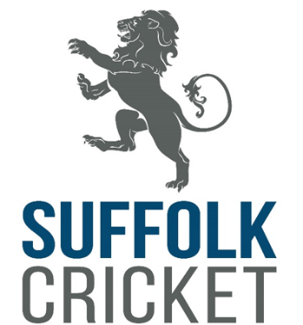

Equality, Diversity and Inclusion
Action Plan 2026

Workforce  Recruit, develop & support a diverse workforce | - Inclusive language in job packs, and ensure any barriers to application are discussed and addressed  - Recruit a NED Director - EDI Lead  - Identify any additional training needs through PDP / review process | - All inductions to include EDI information  - Ensure diversity on every recruitment panel | - Prepare application to Strategic EDI for a Club Support Inclusion Officer  - Maintain the gender diversity within the Board | - Any new staff to have received the EDI Workshops 1 & 2 and completed any mandatory training  - Support clubs to have open dialogue about EDI within their club and encourage volunteers from diverse communities
Communities  Develop & support an inclusive and diverse cricket community | - Work with clubs to be open and welcoming to players from diverse communities  - Develop the disability pathway program in partnership with our neighbouring counties  - Increase the number of young people accessing cricket through schools from areas of deprivation and access FSM | - Work with relevant partner agencies to ensure cricket is accessible to diverse communities (Active Suffolk, CAS, BSC Multicultural Services  - Increase the number of Disability Champion clubs | - Make marketing and promotion materials available in accessible formats and languages where appropriate  - Utilise translation services to support clubs with language barriers  - Increase playing opportunities to young people within state school | - Establish an additional walking cricket hub in the west  - Engage new SEND schools to participate in Lord Taveners program  - Offer club support meetings / workshops / training opportunities to support them with their EDI & governance
Players  Deliver appropriate, inclusive and accessible opportunities to participate in cricket | - Utilise bursaries to remove barriers to participation for participants in low income families | - Increase the number of young people within Super 1 Hubs  - Utilise bursaries within National Programs | - Remodel the Cub Hub program to offer more appropriate training and playing opportunities | - Increase the number of girls within the Cub Hub program
Women & Girls  Drive the provision of opportunities for women & girls across all areas of the game | - Deliver an Intro to Umpiring course for Women and Girls  - Deliver a women’s indoor softball league | - Deliver three Girls only Dynamo programmes in identified clubs  - Deliver girls only school festivals | - Support the 2 Counties league manage and administer the competitive opportunities for Women | - Work with existing Women’s leagues to develop a more joined up competitive offer  - Support clubs to encourage more women onto committees and into voluntary roles  - Plan Coach Development opportunities for those in the Women’s game
Impact  Use the power of cricket to deliver social impact | - Utilise social media and media channels to promote the involvement in cricket | - Deliver Young Cricket Collective to develop skills for young people | - Offer voluntary opportunities to Young Cricket Collective to gain real life experience | - Utilise good news stories to demonstrate our impact

